**1.DEMOGRAPHIC DISTRIBUTION**

SELECT Gender, City, State, Country, Continent, EXTRACT(YEAR FROM CURRENT_DATE) - EXTRACT(YEAR FROM Birthday) AS Age, COUNT(*) AS Customer_Count FROM processed_customers GROUP BY Gender, City, State, Country, Continent, Age ORDER BY Gender, Age;

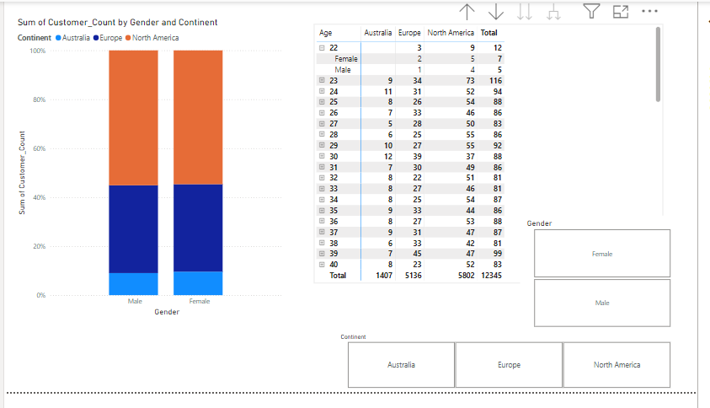

2.PURCHASE PATTERNS

SELECT

CustomerKey,

COUNT(Order_Number) AS Total_Purchases,

AVG(Unit_Price_USD * Quantity) AS Average_Order_Value,

SUM(Unit_Price_USD * Quantity) AS Total_Spend

FROM

Processed_sales

JOIN

processed_products ON processed_sales.ProductKey = processed_products.ProductKey

GROUP BY

CustomerKey

ORDER BY

Total_Spend DESC;

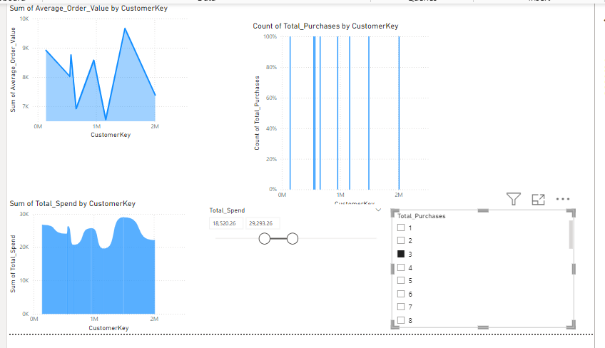

3.Customer Segmentation

SELECT Gender, Continent, COUNT(*) AS Number_of_Customers, AVG(Unit_Price_USD * Quantity) AS Avg_Spend_Per_Customer FROM Customers JOIN Sales ON Customers.CustomerKey = Sales.CustomerKey JOIN Products ON Sales.ProductKey = Products.ProductKey GROUP BY Gender, Continent ORDER BY Avg_Spend_Per_Customer DESC;

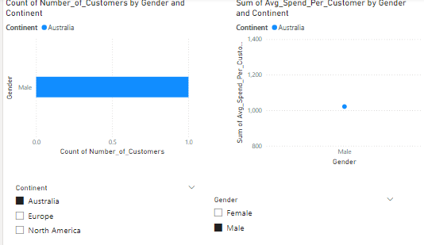

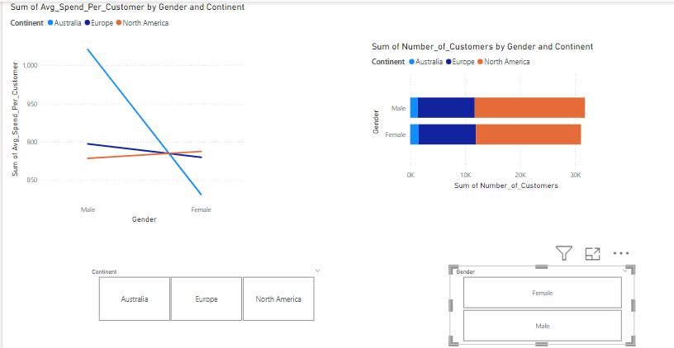

4.Overall Sales Performance

SELECT

EXTRACT(YEAR FROM Order_Date) AS Year,

EXTRACT(MONTH FROM Order_Date) AS Month,

SUM(Unit_Price_USD * Quantity) AS Total_Sales

FROM

processed_sales

JOIN

processed_products ON processed_sales.ProductKey = processed_products.ProductKey

GROUP BY

Year, Month

ORDER BY

Year, Month;

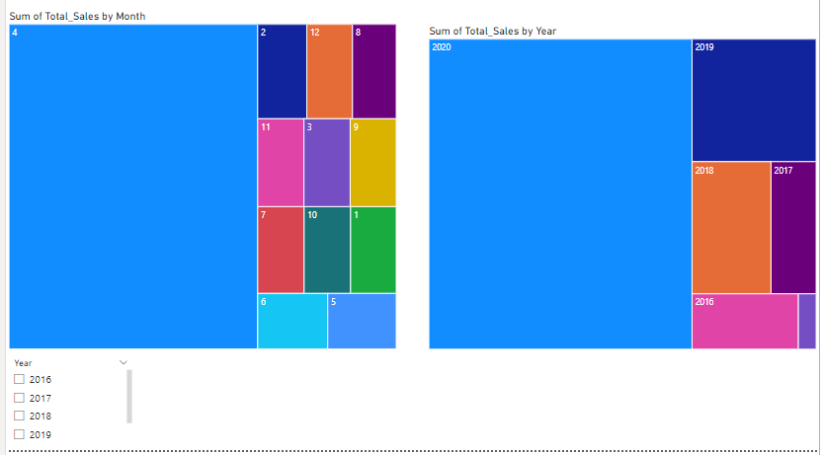

5. Sales by Product

SELECT

Product_Name,

SUM(Quantity) AS Total_Quantity_Sold,

SUM(Unit_Price_USD * Quantity) AS Total_Revenue

FROM

processed_sales

JOIN

processed_products ON processed_sales.ProductKey = processed_products.ProductKey

GROUP BY

Product_Name

ORDER BY

Total_Revenue DESC;

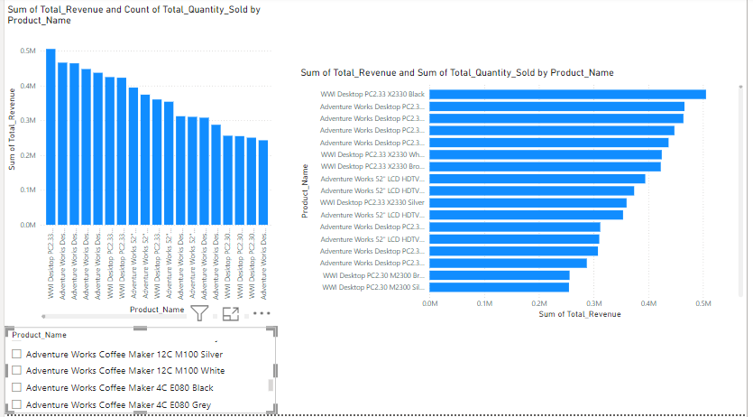

6. Sales by Store

SELECT

ps.StoreKey,

SUM(pp.Unit_Price_USD * ps.Quantity) AS Total_Sales,

COUNT(DISTINCT ps.Order_Number) AS Number_of_Orders

FROM

processed_sales ps

JOIN

processed_stores pst ON ps.StoreKey = pst.StoreKey

JOIN

processed_products pp ON ps.ProductKey = pp.ProductKey

GROUP BY

ps.StoreKey

ORDER BY

Total_Sales DESC;

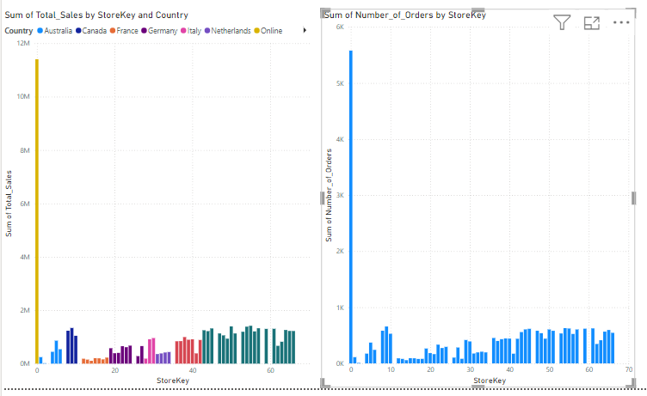

7. Sales by Currency

SELECT

Currency_Code,

SUM(Unit_Price_USD * Quantity) AS Total_Sales

FROM

processed_sales

JOIN

processed_products ON processed_sales.ProductKey = processed_products.ProductKey

GROUP BY

Currency_Code

ORDER BY

Total_Sales DESC;

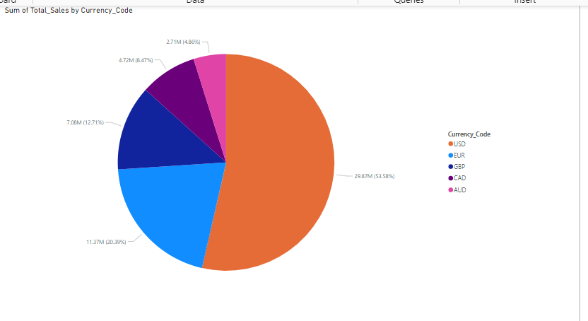

8. Product Popularity

SELECT

Product_Name,

COUNT(*) AS Number_of_Sales,

SUM(Quantity) AS Total_Quantity_Sold

FROM

processed_sales

JOIN

processed_products ON processed_sales.ProductKey = processed_products.ProductKey

GROUP BY

Product_Name

ORDER BY

Total_Quantity_Sold DESC;

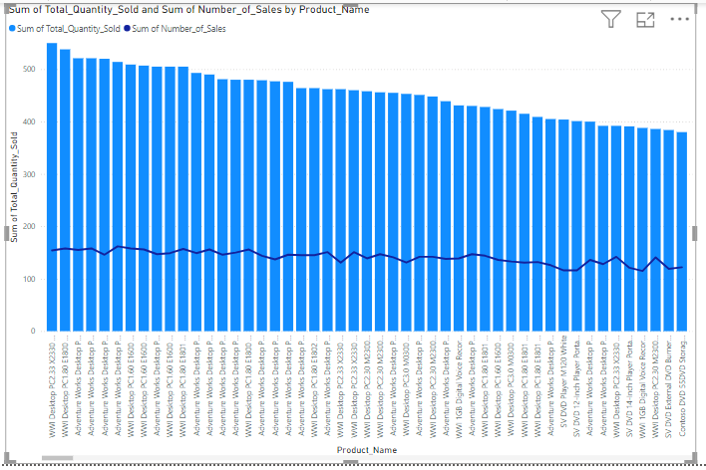

9. Profitability Analysis

SELECT

Product_Name,

Unit_Price_USD - Unit_Cost_USD AS Profit_Margin,

SUM(Unit_Price_USD * Quantity) AS Total_Revenue

FROM

processed_sales

JOIN

processed_products ON processed_sales.ProductKey = processed_products.ProductKey

GROUP BY

Product_Name, Unit_Price_USD, Unit_Cost_USD

ORDER BY

Profit_Margin DESC;

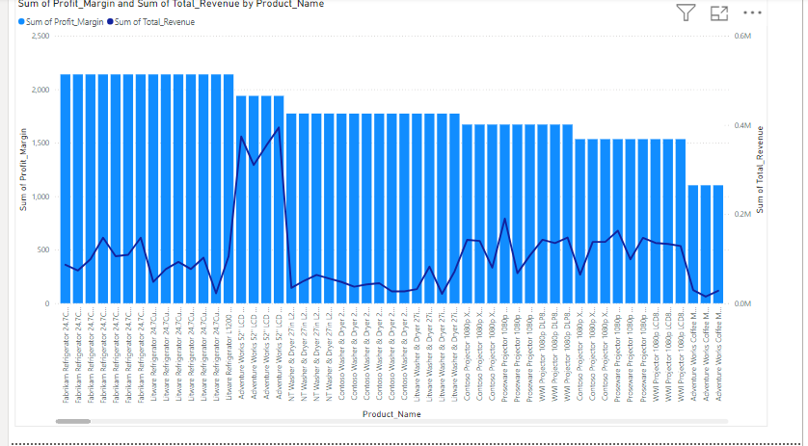

**10.store performance**

SELECT ps.StoreKey, ps.Country, ps.State, ps.Square_Meters, SUM(pp.Unit_Price_USD * psales.Quantity) AS Total_Sales, EXTRACT(YEAR FROM CURRENT_DATE) - EXTRACT(YEAR FROM ps.Open_Date) AS Store_Age FROM processed_stores ps LEFT JOIN processed_sales psales ON ps.StoreKey = psales.StoreKey JOIN processed_products pp ON psales.ProductKey = pp.ProductKey GROUP BY ps.StoreKey, ps.Country, ps.State, ps.Square_Meters, ps.Open_Date ORDER BY Total_Sales DESC;

